**Assignment**

**Learner Details**

* **Name:Nikhil k**
* **Enrollment Number: su625mr004**
* **Batch / Class: Mern Stack**
* **Assignment: role–based navigation system**
* **Date of Submission: 05-08-2025**

**Problem-Solving Activity**

1. **Program Statement**

Create a contact form using React with fields for name, email, and contact number.  
Update the input values using state and event handlers.  
On form submission, display the entered data using an alert message

**2. Algorithm**

Step 1: Initialize three state variables: name, email, and contact.

Step 2: Create input change handlers to update the respective state values.

Step 3: Create a submit handler function for the form.

Step 4: Inside the submit handler, display the form data using an alert.

Step 5: Render a form with input fields for name, email, and contact number.

Step 6: On clicking the submit button, trigger the submit handler.

Step 7: End

**3. Pseudocode**

START

Initialize name as empty string

Initialize email as empty string

Initialize contact as empty string

DEFINE handleName(input):

SET name = input

DEFINE handleEmail(input):

SET email = input

DEFINE handleContact(input):

SET contact = input

DEFINE handleSubmit():

DISPLAY alert( `Name is {name}, Email is {email}, Contact is {contact}`)

DISPLAY form:

Input field for name → onChange calls handleName

Input field for email → onChange calls handleEmail

Input field for contact → onChange calls handleContact

Submit button → onClick calls handleSubmit

END

**4. Program Code**

import React from 'react'

import { useState } from 'react'

const FormAssignment = () => {

const[name,setName]= useState("");

const[email,setEmail]= useState("");

const[contact,setContact]= useState("");

const handleName=(e)=>{

setName(e.target.value)

}

const handleEmail=(e)=>{

setEmail(e.target.value)

}

const handleContact=(e)=>{

setContact(e.target.value)

}

const handleSubmit = () => {

alert(`Name is ${name} and the email is ${email}, contact is ${contact}`);

};

return (

<div className='a'>

<h1 style={{color:"black"}}>Contact Form</h1>

<form onSubmit={handleSubmit}>

<div className='b'>

<label htmlFor="name" style={{color:"black"}}>Enter your name: </label>

<input type="text" onChange={handleName} value={name} style={{backgroundColor:"white"}}/> <br /><br />

<label htmlFor="email" style={{color:"black"}}>Enter your emailId: </label>

<input type="email" onChange={handleEmail} value={email} style={{backgroundColor:"white"}}/><br /><br />

<label htmlFor="number" style={{color:"black"}}>Enter your contact number: </label>

<input type="number" onChange={handleContact} value={contact} style={{backgroundColor:"white"}}/><br /><br />

<button type="submit" >Submit</button>

</div>

</form>

</div>

)

}

export default FormAssignment

**6. Screenshots of Output**

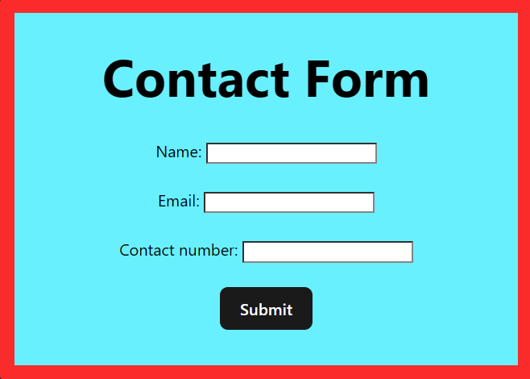

**7. Observation / Reflection**

This task helped me learn how to take input from users using React.  
I understood how to update and use values with the help of state and functions.  
It gave me confidence in handling forms and button clicks in a web page.